EECE.5862 — Embedded Artificial Intelligence

Lab 1 Report — Microcontroller Programming + First TFLite Micro Inference
Name | Himadri Saha
Student ID | 01951522
Course section | EECE.5862 (graduate)
Lab | Lab 1: Microcontroller Programming + First TFLite Micro Inference
Date submitted | 2026-06-07
Instructor | Prof. Yan Luo

1. Objectives
Lab 1 was a refresher in core embedded skills (digital I/O, debouncing, interrupts), introduced TensorFlow Lite Micro, and explored how embedded ML models interact with the hardware real time. It characterized the model’s interactions with the hardware, by verifying that the model’s output can drive physical interfaces quantifying the recourse costs associated with running the model. Overall, lab 1 explored how resource constrained devices behave under real-time pressure.

2. Setup
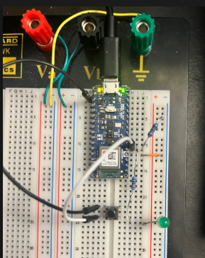
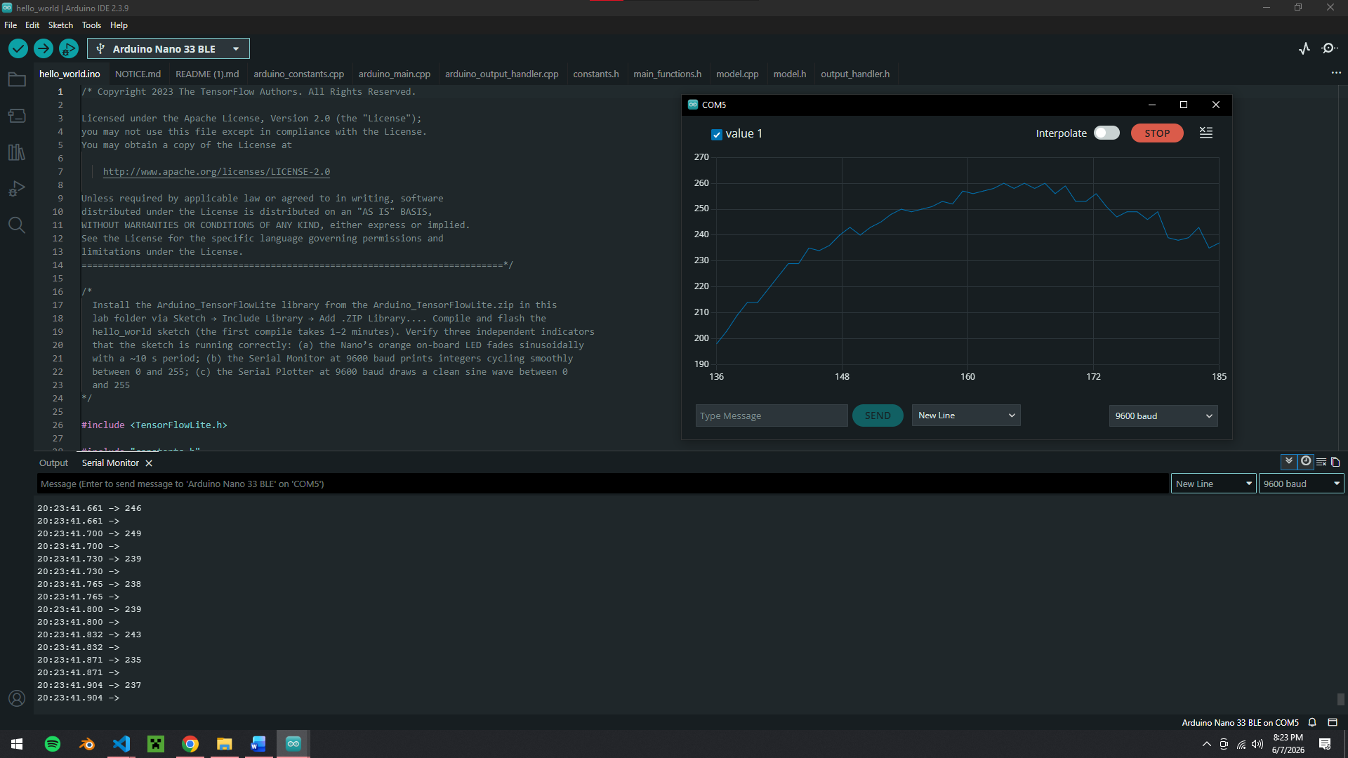
- D3 → one end of the 220 Ω resistor
- Other end of the 220 Ω resistor → LED anode (long leg)
- LED cathode (short leg) → GND

3. Method and Results
C

3.1 Part X.Y — name
W

4. Analysis
C

5. AI Tool Disclosure
Tool | What you asked it (prompt summary) | What it produced | How you modified / verified it
e.g., ChatGPT | … | … | …

6. References
- Iodice, G. M. TinyML Cookbook (2nd ed.). Packt, 2023.
- Arduino. Nano 33 BLE Sense Rev2 documentation. add the specific pages you used.

Submission checklist (delete before submitting)
- This report exported as a single PDF.
- Title page complete; every italic prompt replaced.
- One Method-and-Results subsection per graded part.
- All required photos / screenshots / serial logs included and captioned.
- Analysis paragraphs answer the handout’s specific questions.
- AI Tool Disclosure completed (Yes/No + table if Yes).
- References listed.
- Companion files uploaded to Canvas alongside the PDF: a .zip of all your sketches, with a README.md inside listing each sketch and what it does.

